SESSION 1 — ACTIVITY (20 MIN)
• STUDENT HANDOUT (Set 40 of 40 — every set uses different data)
Decode the Chart
Name: R.YASHIKA Roll No: 192525102
For each chart below, answer: What is it trying to tell you? Do you trust it? Why or why not?
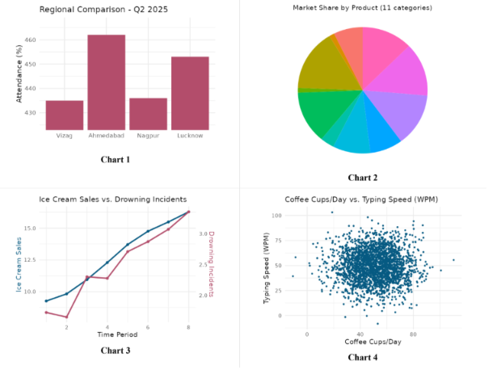
Chart 1 – Regional Comparison
- What is it telling you? Ahmedabad has the highest attendance, while Vizag and Nagpur have lower attendance. Lucknow is also relatively high.
- Do you trust it? Why/why not? Yes, mostly, because the bar chart makes the regional differences easy to compare. However, I would want to know the number of students and the data source before making a strong conclusion.

Chart 2 – Market Share by Product
- What is it telling you? The market is divided among several products, with some products having larger shares than others.
- Do you trust it? Why/why not? Partly, because a pie chart shows proportions clearly, but the exact percentages and product names are not clearly shown.
Chart 3 – Ice Cream Sales vs. Drowning Incidents
- What is it telling you? Both ice cream sales and drowning incidents generally increase over the same time period.
- Do you trust it? Why/why not? Not completely. The chart shows a relationship, but it does not prove that ice cream sales cause drowning incidents. A third factor, such as hot weather or summer, could affect both.
Chart 4 – Coffee Cups/Day vs. Typing Speed
- What is it telling you? The points are widely scattered, so there does not appear to be a strong relationship between coffee consumption and typing speed.
- Do you trust it? Why/why not? Yes, to some extent, because many data points are shown. However, more information about the participants and how the data was collected would make the conclusion more reliable.

